**CRYPTOGRAPHY** Omar Salih

Install and configure GNU privacy guard (GNUPG)

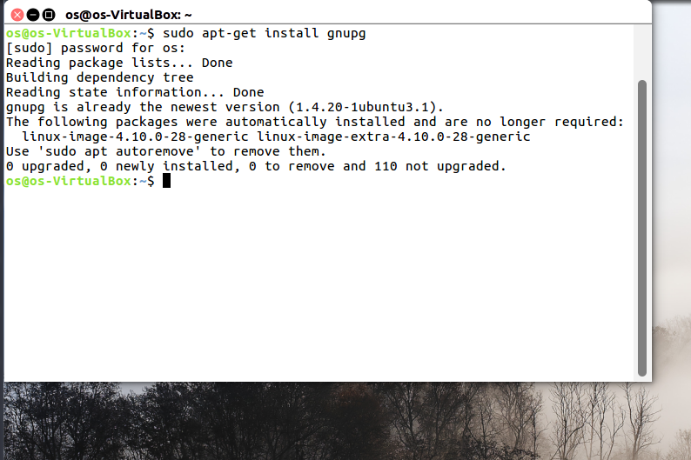

------------------------------------------------------------------------------------------------------------------------------------------------------------------------------------------------------------------------

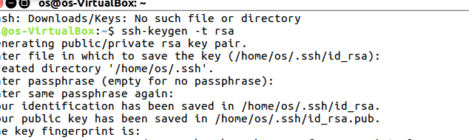

------------------------------------------------------------------------------------------------------------------------------------------------------------------------------------------------------------------------

Generate a SHA1 hash from the command-line in Linux

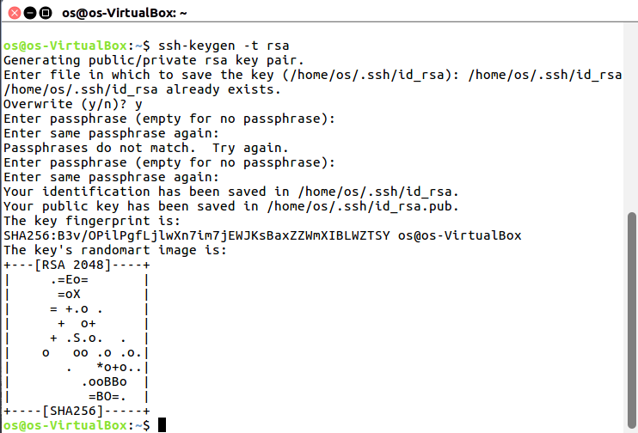

-------------------------------------------------------------------------------------------------------------------------------------------------------------------------------------------------------------------------------------

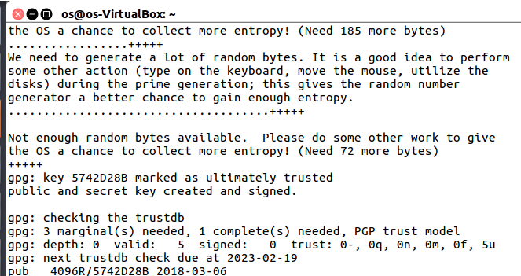

------------------------------------------------------------------------------------------------------------------------------------------------------------------------------------------------------------------------

------------------------------------------------------------------------------------------------------------------------------------------------------------------------------------------------------------------------

Install and configure TrueCrypt

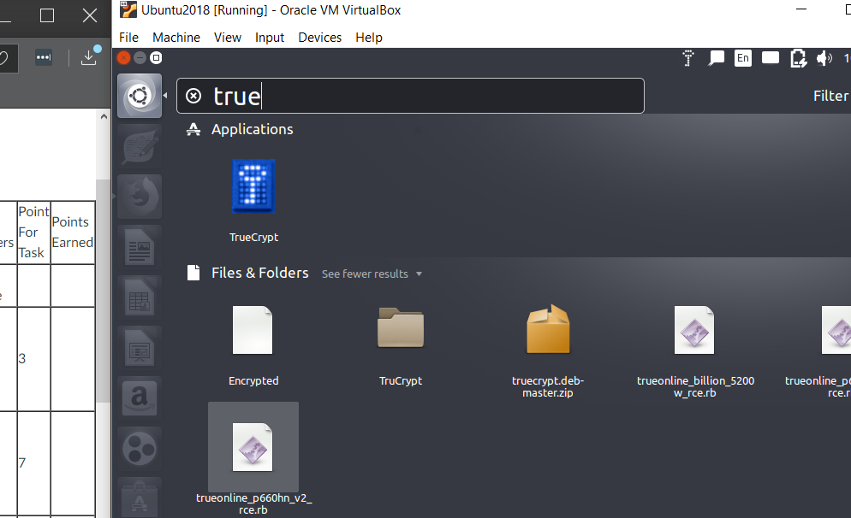

------------------------------------------------------------------------------------------------------------------------------------------------------------------------------------------------------------------------

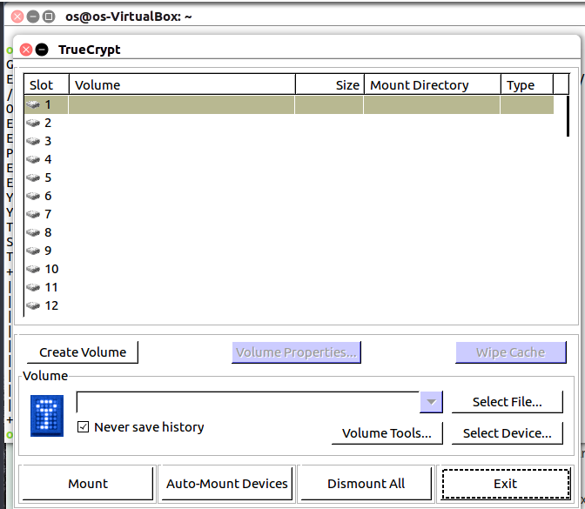

------------------------------------------------------------------------------------------------------------------------------------------------------------------------------------------------------------------------

Send encrypted email (includes exchanging digital certificates and decrypting email)

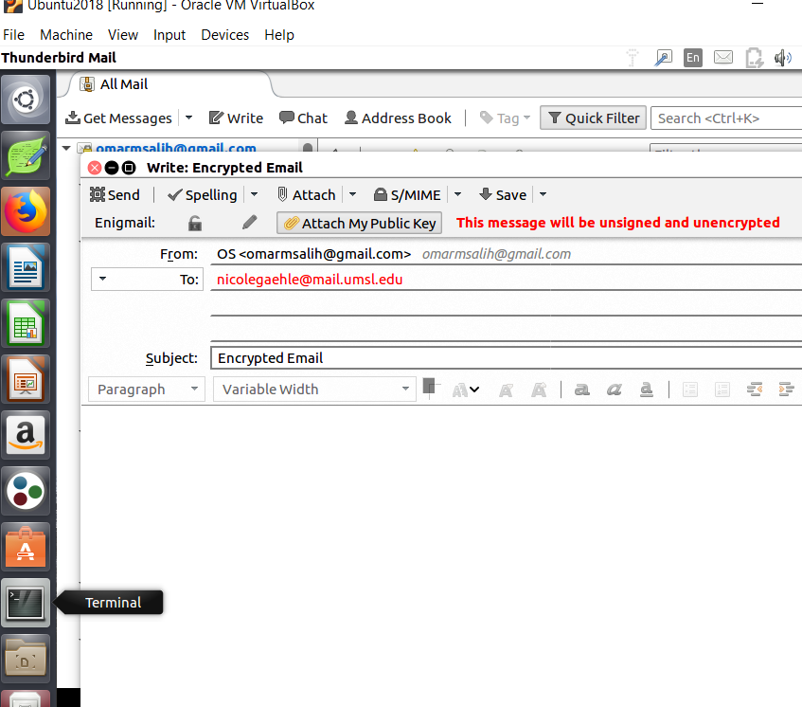

------------------------------------------------------------------------------------------------------------------------------------------------------------------------------------------------------------------------

Decrypted Email

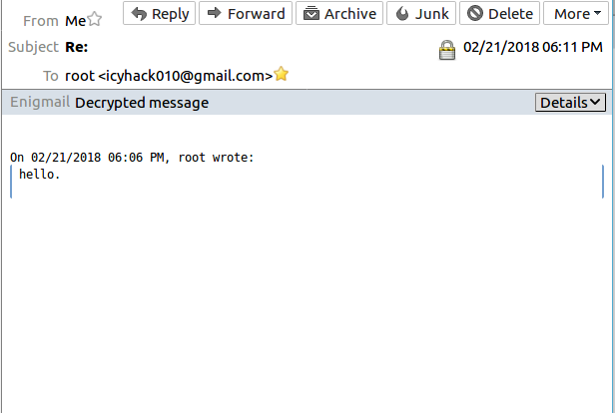

------------------------------------------------------------------------------------------------------------------------------------------------------------------------------------------------------------------------

Install and configure TOR (includes performing a search)

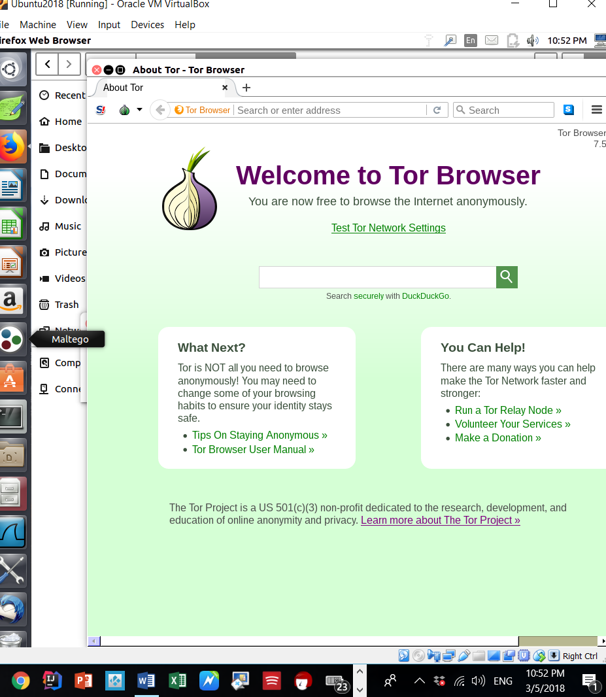

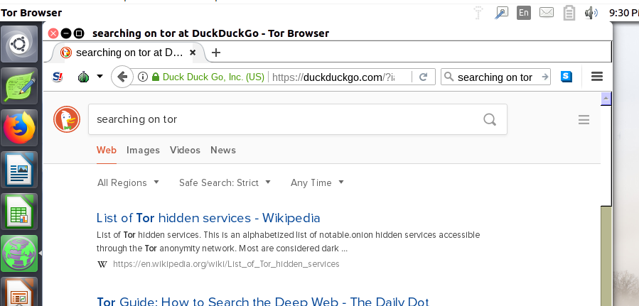

------------------------------------------------------------------------------------------------------------------------------------------------------------------------------------------------------------------------

Perform a basic stenography encryption



Install Steghide

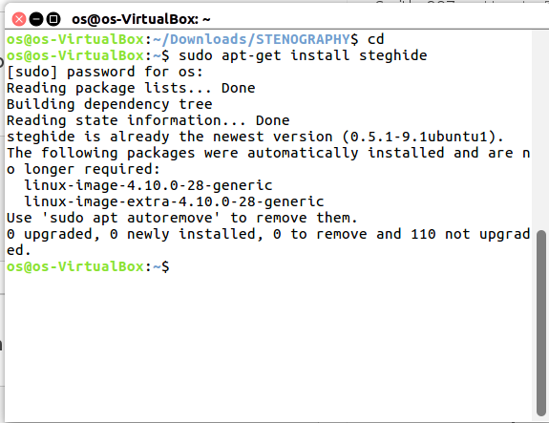

Embed File into JPEG

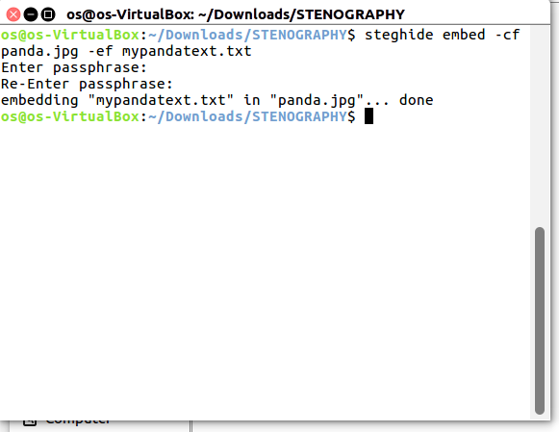

Extract Embedded File



